4.7 Optimization

Motivation: In this section we want to use what we have learned about differential calculus to solve some applied optimization problems. The following outline gives us a way of approaching optimization problems in general.

Guidelines for Optimization Problems
- Understand the problem
- Draw a diagram
- Introduce notation and assign symbols
- Determine what you are trying to maximum/minimize (Suppose we call this M)
- Express M in terms of other symbols
- Use the given information to express M in terms of a single variable.
- Take the derivative of the function M. Find and verify the existence of an absolute minimum/maximum.

Note: We will not list these steps out when solving problems, but we will keep them in mind.

Important Formulas:

Volumes:  - Box:  - Sphere:  - Cylinder:  - Cone: | Surface Areas:  - Box (with all 6 sides):  - Cylinder:  - Cone: (where s is the slant height)
You should also know formulas for areas, circumference, and diameter.

The following theorem will be important for step 7 in the guidelines for optimization problems.

Theorem (First Derivative Test for Absolute Extreme Values):
Suppose that c is a critical number of a continuous function defined on an interval.
- If for all and for all , then is the absolute maximum value of .
- If for all and for all , then is the absolute minimum value of .

Example 1: A farmer has 2400ft of fencing and wants to fence off a rectangular field that borders a straight river. He needs no fence along the river. What are the dimensions of the field that has the largest area?

We want to maximize the area of the field.
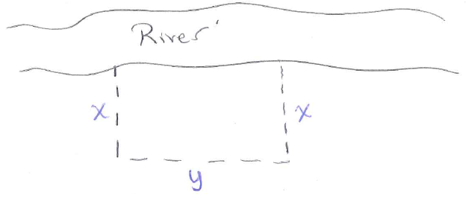
If A represents the area of the field then . We are also told that we have the restriction that .

We want to maximize A, however do this we first need to write A as a function of one variable. To do this we note that:

which implies that

Now we can find the critical values of A, and see if any correspond to an absolute maximum.
is never undefined.

We must check to see that corresponds to a maximum area.
$$600$$
$$+$$
$$-$$
$$MAX$$

does correspond to a maximum area.

We also see that if , then and therefore the dimension of the field with the largest area is 600ft by 1200ft.

Example 2: A factor needs to make a cylindrical can which holds of oil. Find the dimension of the can (i.e., the radius and height) that will minimize the amount of the metal needed to manufacture the can. Round your final answer to the nearest hundredth.

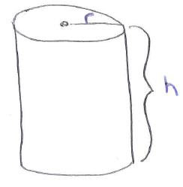
We want to minimize the surface area of the can.
If SA represents the surface area of the can then .
We are also told that the volume of the can is

We want to maximize SA, however do this we first need to write SA as a function of one variable. To do this we note that:

which implies that

Now we can find the critical values of SA, and see if any correspond to an absolute minimum.
is undefined when .

Since we know that we will not be able to construct a can with radius 0 we only need to see if corresponds to a minimum surface area.

$$\sqrt[3]{\frac{500}{π}}$$
$$-$$
$$+$$
$$MIN$$

The value does correspond to a minimum surface area.
We note that if then

Example 3: Find the point on the parabola that is closest to the point .
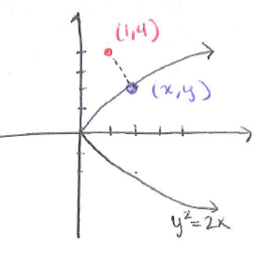
We want to minimize the distance from the parabola the point .
If D represents the distance from the parabola to the point , then we can say (by the Pythagorean Theorem) that We also know the relationship between x and y satisfy the equation .

We want to minimize D, however we may note that whatever value would minimize D would also minimize . Do this we first need to write as a function of one variable. To do this we note that:

which implies that

Now we can find the critical values of , and see if any correspond to an absolute minimum.
is never undefined.

We must check to see that corresponds to a minimum distance.

$$2$$
$$-$$
$$+$$
$$MIN$$

The value does correspond to a minimum value.
If then
Therefore, the point on the parabola that is closest to the point is the point .

Example 4: An oil refinery is located on the north bank of a straight river that is 2km wide. A pipline is to be constructed from the refinery to storage tanks located on the south bank of the river 6km east of the refinery. The cost of laying pipe is $400/km over land to a point P on the north bank and $800/km under the river to the tanks. To minimize the cost of the pipeline, where should P be located? What is the minimum cost of the pipeline?
$$P$$
$$Refinery$$
$$Storage Tanks$$
$$pipeline$$
$$2$$
$$x$$
$$\sqrt{x^{2}+4}$$

We want to minimize the cost of the pipeline.
If C represents the cost of the pipeline, then (where we are assuming that ).

We want to minimize C, and fortunately is already a function of one variable, so we can now find the critical values of C, and see if any correspond to an absolute minimum cost.
is never undefined.

We must check to see if corresponds to a minimum cost.
$\frac{2}{\sqrt{3}}$
$$-$$
$$+$$
$$MIN$$

The value does correspond to a minimum value.
Therefore the pipeline should be built to cross the water at km downstream from the refinery.
The minimum cost of the pipeline is .

